RHT1490J
The RHT1490J is a high frequency Stratum 3 TCXO specifically designed to meet telecommunications grade stabilities at high frequencies with low phase jitter. This product’s frequency output enables lower system jitter, allowing communication system architects to optimise noise budget and performance. Having the optimal balance between close-in phase noise and the noise floor, makes it suitable to be the single reference clock used for both network and air interface requirements. Its ultra-low noise floor performance helps to achieve very low system clock RMS jitter levels need in high speed interfaces (40G/100G).
Comfortably achieving Stratum 3 grade stability, its CMOS output generates < 200 fs of RMS phase jitter (12 kHz – 20 MHz), in a 14 x 9 mm SMD package. An ideal reference clock solution for SyncE and Packet clock requirements (ITU-T G.813, G.8262, G.82673.2 and G8273.3), it also works with both discrete and integrated IEEE 1588 solutions – providing excellent medium term stability for low loop bandwidth applications.
Features | Applications |  | 14.4 x 9.2 x 4.7 mm
- Telecommunications grade Stratum 3 stability  - Low jitter < 200 fs (12 kHz to 20 MHz)  - High frequency options from  50 – 200 MHz  - Inherent airflow resistance | - Stratum 3 equipment  - Carrier Ethernet/Microwave  - Telecom PLLs  - ITU-T G.813, G.8262, G.82673.2 and G8273.3  - Radio Head Clock Recovery  (IEEE 1588/SyncE)  - 10/25/40/100G Ethernet |  | 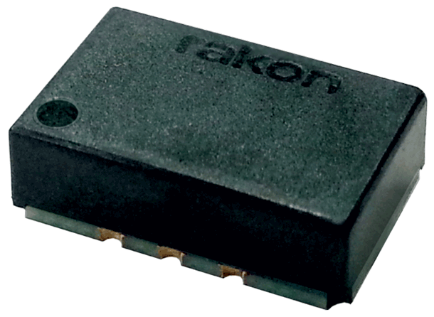

Standard Specifications
Parameter | Min. | Typ. | Max. | Unit | Test Condition / Description
Nominal frequency |  | 50 – 200 |  | MHz | Standard frequencies: 98.304, 100, 125, and 156.25 MHz
Frequency calibration |  |  | ±1.0 | ppm | Initial accuracy at 25°C ±2°C
Reflow shift |  |  | ±1.0 | ppm | Pre to post reflow ∆F (measured ≥ 60 minutes after reflow)
Operating temperature range | -40 |  | 85 | °C
Frequency stability over temperature |  |  | ± 0.28 | ppm | The default reference for holdover stability, variable temperature is (F_{MAX} + F_{MIN})/2
Free-run accuracy |  |  | ±4.6 | ppm | Including frequency calibration, temperature, supply voltage & load changes and 20 years ageing
Supply voltage stability |  |  | ±0.1 | ppm | ±5% variation, reference to frequency at 3.3 V
Load sensitivity |  |  | ±0.1 | ppm | ±5 pF variation, reference to frequency at 5 pF
Long term stability (ageing at 40°C) |  |  | ±10  ±2.5 | ppb  ppm | Per day, after 10 days of continuous operation  20 years
Acceleration sensitivity |  | 2 |  | ppb/g | Gamma vector, 3 axes, 30 – 1500 Hz
Start-up time |  |  | 1 | ms | 90% amplitude
Supply voltage (V_{DD} ) |  | 3.3  2.5 |  | V | ±5%, Fn = 50 – 160 MHz  ±5%, Fn = 160 – 200 MHz
Supply current |  |  | 14 | mA | 5 pF//1 kΩ, 100 MHz
Oscillator output - CMOS  Output voltage level low (V_{OL})  Output voltage level high (V_{OH})  Rise time  Fall time  Duty cycle  Load | 80%  45 | 1.2  1.2  5 | 20%  1.5  1.5  55 | Vdd  Vdd  ns  ns  %  pF | With capacitive load of 5pF, 100 MHz  With capacitive load of 5pF, 100 MHz  Measured 20% to 80% Vdd , 5 pF load, 100 MHz  Measured 80% to 20% Vdd , 5 pF load, 100 MHz  Measured at 50% Vdd trigger level, 100 MHz

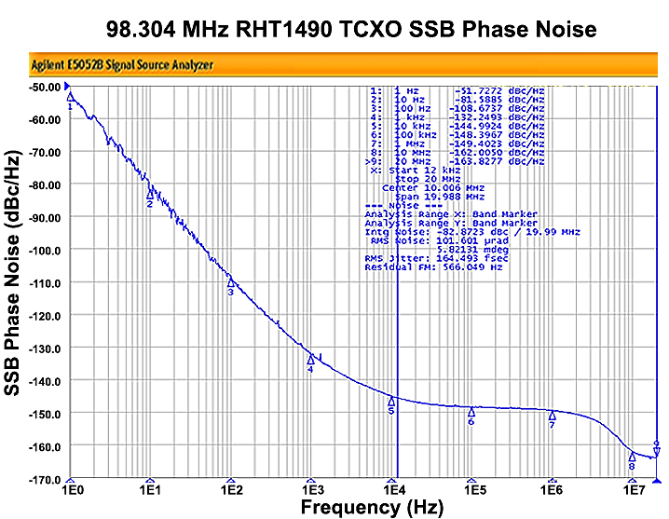
SSB Phase Noise – 98.304 MHz RHT1490 TCXO (Typical value at 25°C, CMOS output)
RMS Jitter = 165 fs
(typ. 12 kHz ~ 20 MHz)

Model Outline, Recommended Pad Layout
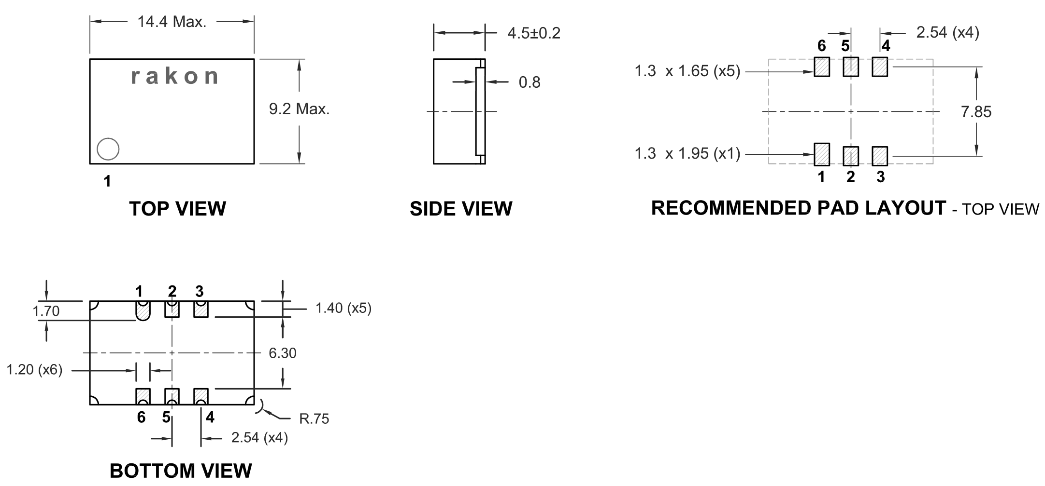
Pin Connections
1 | GND
2 | Do not connect
3 | GND
4 | Output
5 | Do not connect
6 | Supply Voltage (Vdd)

NOTE:
Outline unit is mm.

Test Circuit
